Assignment 7

Jashjeet Singh Madan

6 a)

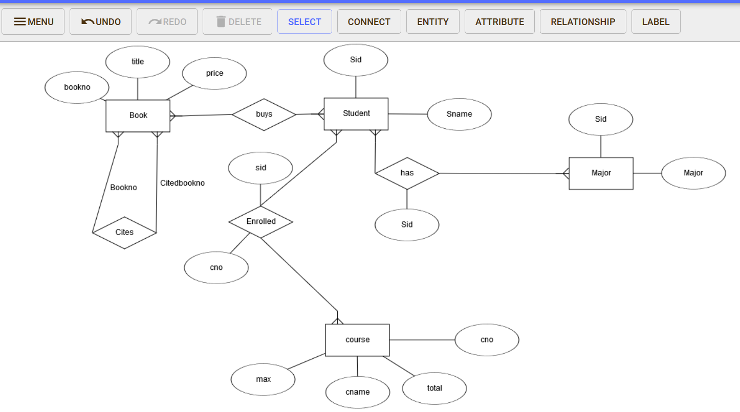

6 b)

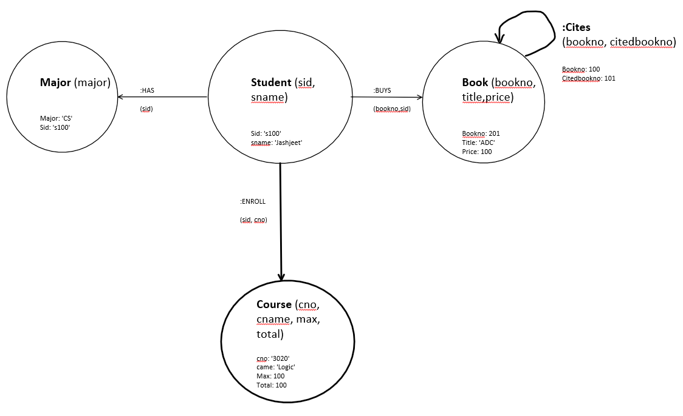–

Q. 7

(a) MATCH (:Student) – [r] -> ()

RETURN distinct type(r)

(b) MATCH (s:Student) – [:Buys] -> (b:Books)

WHERE s.sname = ‘John’ AND b.price >= 50

RETURN s

(c) MATCH (s:Student) – [:Buys] -> (b1:Books) – [:cites] -> (b2:Books)

WHERE b2.price >= 50

RETURN s

(d) MATCH (b1:Books{price>50}) – [:cites\*] -> (b2:Books)

RETURN b2

--Help taken from Harsha

(e) MATCH (s:Student) – [:has] -> (m:Major),

(s:Student) <- [:Buys] – (b:Books)

WHERE m.major = ‘CS’ AND m.major = ‘Math’

RETURN b, count(s)